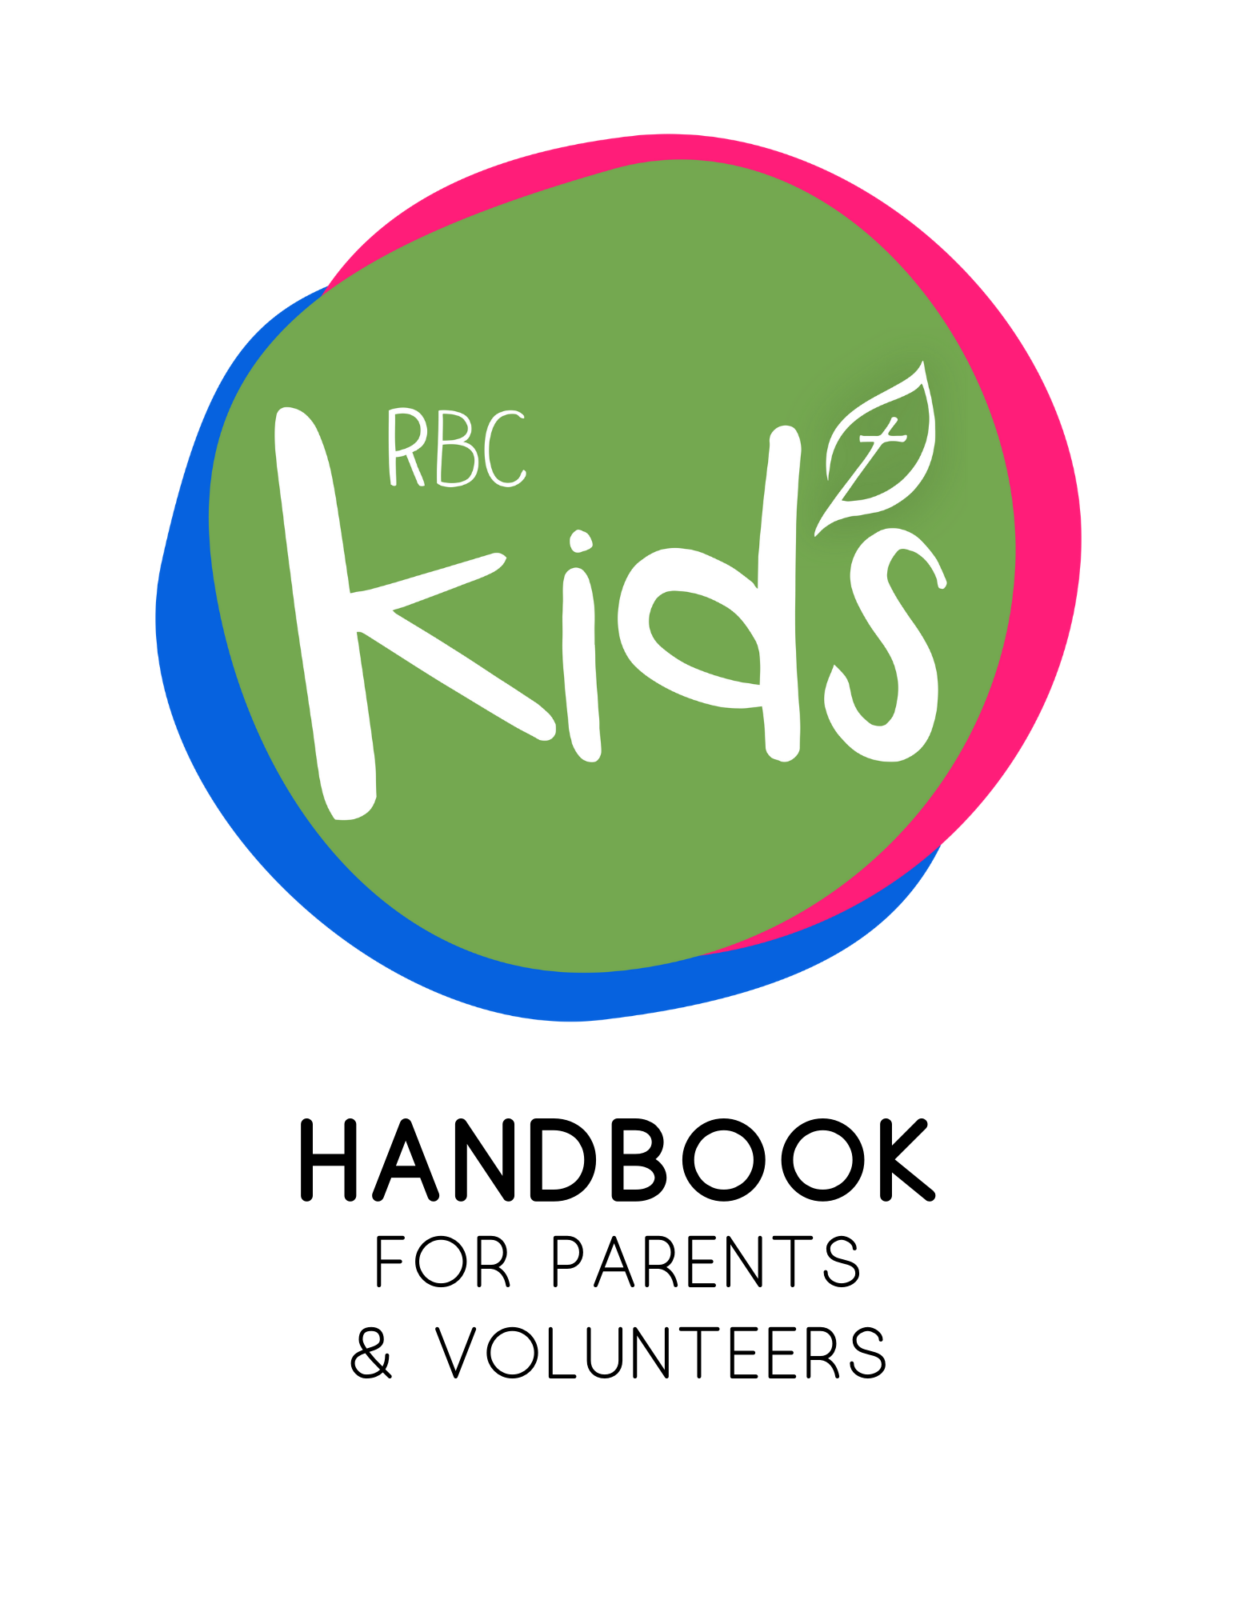Table of Contents

- Philosophy of RBC Kids Ministry Pg. 3
- Policies Pgs. 4-13
A. Safety and Security (pgs. 4-5)
B. Wellness (pgs.6-7)
C. Medical Concerns (pg. 7)
D. Emergency Procedures (pgs. 7-9)
E. Restroom and Diapering (pgs. 10-11)
F. Hygiene and Sanitation (pg. 11)
G. Discipline (pgs. 12-13)
- Team Members Pgs. 13-20
H. Requirements prior to serving (pgs. 13-14)
I. Responsibilities/Expectations (pgs. 14-15)
J. Practical tips for leading kids well/ Classroom Management (pgs. 15-20)
- Incident Report Pg. 21

Philosophy of Children's Ministry

RBC Kids exists to glorify God by making Christ-centered, relationship-driven disciples of all people. We aim to do that in a few ways:

- We are going to pray for the children of the church and the community. We believe that every child is in need of the Holy Spirit and that it isn't in our power to make a child believe. We will pray that God works in the hearts of these children and turns their eyes towards Jesus as their only hope.
- We believe that scripture is clear that parents are the primary disciple makers in the lives of their children. Our hope is to partner with parents and caregivers in pursuit of this mission. We will come alongside them in the discipleship process and equip them with vital resources.
"Fathers, do not provoke your children to anger, but bring them up in the discipline and instruction of the Lord." Ephesians 6:4
"We will tell the next generation the praiseworthy deeds of the Lord, His power, and the wonders He has done." Psalm 78:4
- We are going to teach children the Gospel and how to apply it to their lives. God has given us good news through his word so we are going to be diligent to read scripture with the children.
"In the beginning was the Word, and the Word was with God, and the Word was God. He was in the beginning with God. All things were made through him, and without him was not any thing made that was made. In him was life, and the life was the light of men. The light shines in the darkness, and the darkness has not overcome it." John 1: 1-5
- Every Sunday, Wednesday, and during all church sponsored events, all children will experience a safe, age-appropriate environment where the Bible is taught in a creative and relevant way.
Policies

A. Safety & Security:
This is a general overview of safety and security guidelines. More detailed information can be found in the RBC Policies and Procedures to Prevent Child Abuse In Children’s and Youth Ministries.
Please follow these rules to make sure our children are safe:

Stranger in the hall
Only parents/guardians, Children's Ministry leaders, church staff, and children are allowed in the Children's Ministry area for lengthy periods of time. All other adults (including any other church members) who are loitering should be asked for identification and immediately escorted out of the Children's Ministry Area. If there are any questions or concerns associated with a stranger in the area, the security team member on duty or Children's Minister should be notified immediately to question the stranger.

Check-in policy
1. Classrooms will open 15 minutes prior to regularly scheduled church activities.
2. All parents/guardians MUST accompany their child to check them in at the computer/iPad and then at their classrooms. Please do not check in a child or admit them into the classroom unless a parent or guardian is present.
3. A registration form should be completed either digitally or physically for each new family that checks in.
4. Upon check-in, 2 tags will be printed. One will be a name tag to be placed on the child's shirt where it can be seen and the other a security claim tag. All tags will have an alphanumeric code corresponding to one another within a family group.
For Example: John and Jane Doe’s nametags will have a random 3 letter code in the top right of their nametags. Today it is ZIP. Today’s security claim tag will correspond by also saying ZIP. You only need 1 security claim code per family, but you must show it at each classroom.
5. Upon classroom drop-off, ensure that the child is wearing a visible name tag.

Check out policy
1. Classrooms will close fifteen minutes after the completion of our worship services and activities.
2. A child may not be released unless a parent/guardian has the security tag which corresponds to the name tag on that child. If an adult attempts to pick up a child without the corresponding security tag, the leader must ask to see the adult's driver's license. If the adult's relationship to the child can be validated, then the leader may release the child. In the case that the adult's relationship to the child cannot be verified, then the Children’s Minister must be notified to make the decision to release a child.
-Parents/guardians may contact the Children’s Minister in the event of an emergency and if the person picking up will not/does not have the pick-up tag.

Serving
The role of RBC Kids is to partner alongside parents and guardians in the discipleship of their children. Because this is a partnership, we ask that at least one parent/guardian from each family serve in the kid’s ministry at least once per month.

B. Wellness:

If your child is sick, please respect others by keeping him or her with you. If your child shows signs of sickness (including, but not limited to, high fever, vomiting, diarrhea, severe coughing, colored nasal drainage, pink eye, head lice, undiagnosed rash, open skin lesions, and any infectious disease), we reserve the right to ask you to remove him or her from the classroom.

If you or your child is sick on Friday at Noon or become sick after Noon on Friday, and you are scheduled to serve on Sunday, go ahead and find your substitute. Please do not wait until Saturday or Sunday to try and find a substitute. It is better to have a substitute and not need it, than to not have enough teachers.

Children who appear, or become, ill at church will be isolated from the other children, and the parent/guardian will be summoned immediately.

Parents are asked to contact the RBC Children’s Minister leadership if their child contracts a communicable disease (such as chicken pox, head lice, filth disease, etc.) after attending a RBC Kids gathering.

The medical condition of any child or RBC Kids team member will be disclosed only to the extent necessary to minimize the health risk to the person and others. The RBC Staff and the RBC Kids leadership team will be provided with the appropriate information concerning any special precaution that may be necessary. RBC Kids will not disclose the health status of any individual without the express written consent and permission of that individual, or in the case of a child, their parent or guardian. Parents of children involved in RBC Kids activities will not be privy to any confidential medical information.

The RBC Kids sickness policy exists for the protection of the children in our care. We regret that it sometimes means not admitting children that have been brought to our public gatherings.

C. Medical Concerns:

First Aid or Injuries
Although we strive to maintain the safest environment possible, it is known that the nature of children's activities occasionally leads to accidents. It is the policy of RBC Kids to first notify the child's parents/guardians in the event of a medical incident. In the event that the parents are not immediately available, childcare workers will administer appropriate treatment measures such as applying pressure or a bandage to a bleeding wound. No pharmacological treatment, oral or topical, will be administered. Life-threatening situations will, of course, be handled as emergencies with appropriate treatment measures being immediately instituted. 911 and parents will be notified immediately.

D. Emergency Action Plan:
In case of an emergency, do the following:
Be able to account for every child in your classroom, by name, at all times.

Hazardous Weather
In the event of dangerous weather leaders should follow the guidelines below. Further instructions will be given by the Children's Minister.
1. Stay calm.
2. Move your classroom in a quiet and orderly manner to the designated interior area according to the map in your classroom.
3. Take your clipboard, paper roster, and cell phone.
4. Keep children calm by reading a book or listening to music.
5. Await further instructions.
6. If a parent/guardian attempts to check-out their child while in route to or in the safe area, please ask them to wait until the Children's Minister has cleared you to do so. Once cleared, use the standard practice of checking a child out to their parent/guardian.

Fire
1. Stay calm! If you hear the fire alarm, assume it is real and begin evacuating the children.
2. Familiarize yourself with all the fire exits. Evacuation plans are posted in each room.
3. Evacuate the children in the infants, crawlers, and walkers rooms by using the cribs. Put babies in each crib, no more than 4 babies recommended per crib. Have one adult stay with each crib.
4. Check the room for stragglers. Close the door.
5. Take your clipboard, paper roster, and cell phone.
6. If a parent/guardian attempts to check-out their child while in route to or in the safe area, please ask them to wait until the Children's Minister has cleared you to do so. Once cleared, use the standard practice of checking a child out to their parent/guardian.

Lock Down Procedures
1. Stay calm.
2. Close classroom doors and lock doors.
3. Turn off lights and keep children quiet and calm. Sing, pray, play quiet games, read a story. Children will stay calm if you are calm.
4. Move children to the area of your classroom least visible from the hallways.
5. Do not open the door for anyone. Once the situation is resolved the Children's Minister will unlock the door with a key after stating the password.
6. Please be aware during a lockdown situation due to incalculable variables the procedures mentioned above may be changed in a moment's notice.
7. If a parent/guardian attempts to check-out their child during a lockdown, please ask them to wait until the Children's Minister has cleared you to do so. Once cleared, use the standard practice of checking a child out to their parent/guardian.

Missing Child
1. Time is critical if a child is reported missing. Leaders should contact the Children's Minister as soon as possible with the following information:
- Name/age/sex
- Color of hair, shirt, and skin
- The person reporting the lost child should remain with the staff member until further direction is given by the Children's Minister
- All communication and procedures will be carried out at the direction of the Children's Minister

Media Response
In the event of a severe accident, allegations of abuse, or death, it is likely that the media will be on site to cover the incident. It is important that all leaders say nothing that could be mistaken or misquoted by the interviewer. The Senior Pastor is the only one to make any statement. If asked by a media member for a statement, please graciously decline and direct them to the Children's Minister or Senior Pastor.

E. Restrooms & Diaper Changing:
This is a general overview of restroom and diaper changing guidelines. More detailed information can be found in RBC’s Policies and Procedures to Prevent Child Abuse In Children’s And Youth Ministries.

Restrooms
- The primary restroom in use should be the one in your classroom.
  - If a child needs assistance in the restroom, one adult will offer assistance while either the door is propped open, or they are in view of the second non-related adult.
- If the restroom in the classroom is unavailable, children will travel to the restroom with at least two RBC Kids volunteers. One will offer toileting assistance in a stall if necessary while the other will supervise at the main bathroom door (lining up, hand washing reminders, etc.).

Diaper Changing
Diapers will only be changed in specified changing area (changing tables are located in rooms 137 & 138).
- Disposable gloves will be available for use.
- The child's bottom and buttocks will be cleansed with moist disposable baby wipes provided in the nursery. Parents may provide their own wipes as well.
- The child will be wiped from front to back to help avoid urinary tract infections.
- A new clean diaper will be placed on the child and the diaper will be thrown away. Disposable diapers are in the nursery bin, but parents may provide their preferred disposable as well.
- At completion of the diaper change, the changing surface will be cleansed with a disinfectant wipe.
- RBC Kids volunteers will not change the diaper of a child over the age of 4 years old. In this instance, a parent will be requested to address the diaper change.
  - Children will not leave the nursery on Sundays or Wednesdays until they are potty trained except in rare cases.

F. Sanitation and Hygiene:
- All volunteers will wash their hands with soap and warm water for 60 seconds after using the restroom, offering restroom and diaper assistance to a child, and after handling cleaners.
- Volunteers will use disposable gloves when contact with bodily fluids (blood, stool, urine, nasal drainage, eye secretions, or vomit) is anticipated.
- Gloves will be discarded after a single use with a single child.
- Volunteers will use a disinfectant spray to sanitize areas that are routinely in contact with children, such as diaper changing stations, toys, tables, bouncers, etc. These items should be disinfected after each service, or if necessary, after use by an individual child (toy in mouth, child sneezes on toy, etc.).
  - Cleaning supplies can be found in cabinets in the laundry room found immediately behind the welcome desk on the Kid’s Wing.
- Volunteers will wash hands thoroughly before distributing snacks/water.

G. Discipline:
This is a general overview of discipline guidelines. More detailed information can be found in RBC’s Policies and Procedures to Prevent Child Abuse In Children’s And Youth Ministries.

The effective spiritual formation of all our children requires a stable environment. The role of RBC Kids is to support and supplement parental training by upholding high standards for behavior, respect and discipline. Some of the expectations we have for children include:
  - Every child participates with a willing heart, eager to learn and obey. The attitude should be respectful to authority.
  - The child is to avoid being disruptive or distracting to the mission and purpose of the children's ministry.
  - Disrespect (whether verbally, by gesture, in attitude, or by action) is unacceptable.
  - Misbehavior (including, but not limited to, persistent talking, distracting others, not following instructions ignoring instructions or directions, or interacting inappropriately with others in the class) is unacceptable.

If a child is being disruptive or unruly, team members will give the child verbal warnings, move them to another side of the room, or, if necessary, into the hallway (leaving the door fully open and within sight of other people). If these measures do not resolve the issue, we will page/call you and ask you to come and sit with your child in class the following week, and for as long as necessary until the child can control himself or herself. Since our goal is to assist parents/guardians in the effective training and instruction of children, teachers and Children's Ministry leaders will talk with you about any consistent behavioral problems we are experiencing with your child. Sometimes kids will be kids, and we're okay with that! But Scripture does teach that proper training and expectations are crucial to raising godly children (Proverbs 22:6). We are committed to working with children to find what they need in order to fully participate, but not to the detriment of other children in the class.

A major goal during all disciplinary situations is to help children see that they have sinned against God and their neighbor and to encourage asking for and extending forgiveness.

No child at RBC will be subject to:
- Physical punishment: any striking, spanking, shaking, slapping or other violent behaviors
  - Children may be restrained if they are in danger of hurting themselves or others.
- Verbal/mental abuse: any humiliating, degrading, threatening, or other abusive communication behaviors.

Team Members

H. Requirements:
All team members must submit to the leadership of the RBC Staff and the leadership of the RBC Children’s Minister. Team members must also adhere to all policies and procedures laid out in this handbook and in RBC’s Policies and Procedures to Prevent Child Abuse In Children’s And Youth Ministries.

Every RBC Kids Team Member/Volunteer must complete all onboarding steps before serving in a classroom:
- Background check
  - Every two years
- Signed handbook
  - Every year
- Signed Policies and Procedures to Prevent Child Abuse In Children’s And Youth Ministries
  - Every year

I. Responsibilities/expectations:
Responsibilities of every RBC Kids Team Member/Volunteer are:
- Must be a committed follower of Christ and be invested in a personal and growing relationship with God.
- Be regularly involved in the life of RBC through either Sunday School or Morning Worship.
  - I.e., at least twice a month
- Pray regularly for each student.
- Become familiar with each child’s life and activities such that the child feels personally known and the leader can attend sporting events, recitals, etc. when possible.
- Monitor supply needs in your classrooms and check-in and report back to the Children’s Minister in a timely manner when new supplies are needed.
  - If you need supplies, first check the resource closet and laundry room behind the welcome desk.
  - If you are interested in purchasing supplies and being reimbursed for those supplies, you must get written approval from the Children’s Minister ahead of time.
- Be ready each week to teach the lesson as provided and as scheduled among your co-teachers.
- Support other teachers when it is not your week to lead.
- You are expected to find your own substitute from our list of approved children’s workers.
  - If you need suggestions on who to ask for your role or age group, please reach out to me and I can guide you towards some people you can ask.
    - This needs to be done by Wednesday at Noon unless it is an emergency.
  - If you or your child is sick on Friday at Noon or become sick after Noon on Friday, and you are scheduled to serve on Sunday, go ahead and find your substitute. Please do not wait until Saturday or Sunday to try and find a substitute. It is better to have a substitute and not need it, than to not have enough teachers.
  - Even though you are expected to find your own substitute, I still need to know who is in leadership each week so please keep me updated!
- Have an equal hand in discipline.
  - One teacher should not be the only one involved in discipline, all volunteers should abide by our Child Protection Policy and this handbook in matters of discipline.
- Serve with a desire to see the children of RBC and our community grow into a deep relationship with Jesus Christ and speak truth, even when it is hard.
- Lead the church by example in supporting the Children’s Ministry, including chaperoning and volunteering at events whenever possible.
- Clean space and resources after each session.
- Send a card to kids when they miss 2 weeks in a row
  - We have a stash of cards in the resource classroom available for use.
  - You can bring them to the office for postage.
- Send each child a card for their birthday
- Follow the tips and classroom management strategies as laid out in this handbook (section J).

J. Practical tips for leading kids well/Classroom management:
- Praise the Positive and reward good behavior.
  - Children often learn by modeling behavior.
  - So try, for example “I love the way Sarah is sitting quietly with her hands in her lap. Great job!” The other children will follow quickly in hopes of being praised in the same way.
  - Praising kids rewards good behavior and reinforces it for the entire class. You may also use rewards, such as: obedient children are the first to receive snack or art supplies.
- Explain the rules of the class every week.
  - Children do well when they know what is expected of them.
  - Keep the classroom structure similar from week to week.
    - Having a predictable routine helps kids cope with an environment and understand appropriate behavior.
    - Have specific times when kids are allowed to be out of their seats. When they sit down, let them know the next time they are going to be allowed to get out of their seats.
    - Alternate sitting activities with activities that involve moving or standing. Kids will focus better if you give them a chance to get some of their energy out!
  - Only have out the supplies you need for that particular activity. When time for that activity is over, remove the supplies. If you are coloring, only have coloring supplies out. Once it is time for the Bible story, remove all coloring supplies and coloring sheets and get out the Bibles.
- Be assertive: Say what you mean and do what you say.
  - Children need to know what consequences will follow for disobedience. When children know the consequences ahead of time, they are likely to deal with them with less arguing and complaining.
  - It is best to order your classroom around what you have said you are going to do. You are the teacher. Be firm in giving instructions and following through with what you say. Being firm doesn’t mean being mean!
  - You should never yell at a child. Speak on their level. Look at them in the eye and make sure they are listening to what you say.
  - If appropriate, have them repeat back what you just said.
  - Don’t discipline a child from across the room: go to the child and pull them aside. Do not let kids tell you what to do. You must be in control.
  - Call Children by name. If they are talking while you are talking, engage them by calling them by name and bringing them into the discussion.
- Make things fun!
  - Instead of going into things like clean up time with a negative approach, such as “I’m so sorry, but we have to put toys away now ... “ try addressing it with a positive spin like “OK, kids, I have a mission for you: do you think we can have all of these toys put away in two minutes?”
  - Or, singing the clean-up song is a fun way to begin and encourage a clean-up routine.
  - Don’t offer too many activity choices for kids. Switch out the toys so kids do not become bored.
- Talk to a child who is crying.
  - Engage an upset child with something of interest. Talk to them in a way that distracts them from thinking about their parents and avoid saying that Mommy is coming. If absolutely necessary, you can remind them that Mommy and Daddy will come back soon, but do not make that the point of your conversation.
  - For children who are likely to cry, ask their parents about how to best soothe them.
- Incorporate the Gospel when you are disciplining a child.
  - Focus on God’s love for the child and your love for the child.
  - Be specific as you explain that you want him or her to follow directions, be kind to friends, participate, etc.
  - Talk to the child about how it pleases the Lord when we obey Him.
  - Remember that discipline should always be given in love, not in anger.
- Only give out food approved by the Children’s Minister.
  - For snack during Sunday School, Children’s Worship, Extended Care, Mission Friends, RAs, GAs, etc., the snack will be provided by RBC.
    - Our approved snacks are cheddar goldfish, motts fruit snacks, and water.
      - Snacks and water cups can be found in cabinets in the laundry room, immediately behind the welcome desk on the kid’s wing.
    - If your child is in need of a different snack due to allergies let the Children’s Minister know and we can make arrangements or Parents of children with allergies are welcome to drop off their own snacks for their children at the church office.
    - If you are interested in having a snack other than goldfish and fruit snacks (it fits with your lesson, special party, etc.) it needs to be approved with the Children’s Minister at least two weeks ahead of time so an email can be sent out to parents.
- Have a bucket or container where kids put their personal belongings when they enter the room. They are only allowed to get them out under special or specific circumstances. This keeps the item from being a distraction as well as removes the likelihood of it getting lost or messed up by another child (this can be altered some for our infants and preschoolers)
  - Phones
  - Toys
  - Electronics
- Have children repeat things back to you.
  - Getting kids to respond to you verbally keeps them engaged and gets them reengaged. They are more likely to pay attention, retain, and understand.
    - When stating the scripture for the day ask kids if the book is in the New or Old Testament, what genre it is, etc. Then when you say the chapter number and verse number have them repeat it back and ask them how we know what chapter something is and what verse it is. For example…..
      - “Today we are in the book of Matthew. Is Matthew in the Old or New Testament? (New) What genre is it? (Gospel) That’s right! How many other Gospels are there? (3) What does Gospel mean? (Good news) What are the other Gospels? (Mark, Luke, John). What number book is Matthew in the New Testament? (One). Great, so we are in the Gospel of Matthew in the New Testament and we are going to be in Chapter 7 verse 24. What chapter are we in? (7) and what verse? (24). Now, how do we know which of the numbers is a chapter and which is a verse? (The larger number is the chapter and the smaller numbers are the verses).
        - Etc., obviously for a 3 year old you aren’t going to be going through all of this, but the general idea still remains true. This is a very easy way to help teach the kids Bible Skills without them even realizing it and it is easily added in as kids are finding the passage.
      - I like to explain that the Old Testament is before Jesus’ birth and the New Testament starts with His birth, follows His life, and what happens after He goes back up to Heaven. Even though Jesus isn’t born in the Old Testament, all of Scripture is still telling His story.
    - When explaining rules to a game, stop and have them repeat the rules back.
      - You can stop after each rule, or at the end.
      - Say something like “Do we run or walk?”, “Do we skip or jump?” “How do we win? (by ____)”
- Kids should be using a Bible each week and finding the passage themselves.
  - It can be tempting to find it for them, but they need to find it. You can help them find it by pointing them to the table of contents, or verbally helping them figure out where to look, but don’t just find the passage for them.
  - We want our kids to be skilled at using their Bibles on their own. They can’t read it at home if they don’t know how to use it.

Accident/Incident Report

Name:________________________

Date & Time:________________ Location:_________________

Describe Accident/Incident:______________________________
_____________________________________________________
_____________________________________________________
_____________________________________________________

Describe nature of injury:_________________________________
______________________________________________________
______________________________________________________
______________________________________________________

What action was taken?__________________________________
______________________________________________________
______________________________________________________
______________________________________________________

Describe medical treatment/first aid:_______________________
______________________________________________________
______________________________________________________
______________________________________________________

RBC Children’s Minister’s Signature:__________________________

Teacher Signature:________________________________________

Parent/guardian signature:_________________________________

